ASM-WAF-SQS-MQ-Assignment

ASM

Task Title
Configure EC2 to Retrieve Database Credentials from AWS Systems Manager Parameter Store

Objective
To securely store database credentials in AWS Systems Manager Parameter Store and automatically retrieve them on an EC2 instance during launch using user data, avoiding hard-coding secrets in scripts or configuration files.

Prerequisites
- Active AWS Account
- IAM User with EC2, IAM, and SSM permissions
- Existing database connection details (hostname, username, password)
- SSH key pair to access EC2
- AWS CLI pre-installed (optional for validation)

Step-by-Step Implementation

1️⃣ Create Parameters in AWS Systems Manager
a. Navigate to:
AWS Console → Systems Manager → Parameter Store → Create Parameter
b. Create first parameter
Field | Value
Name | ps-db-password
Type | SecureString
KMS Key | alias/aws/ssm
Value | YourDatabasePassword
c. Create second parameter
Field | Value
Name | database-url-ps
Type | String
Value | mysql://database-hostname:3306/mydb

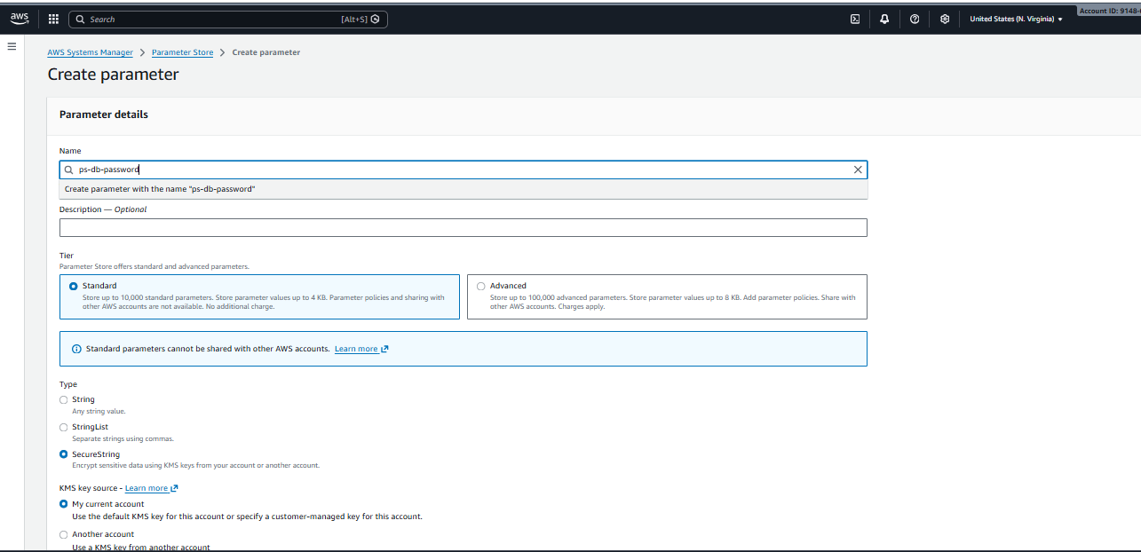
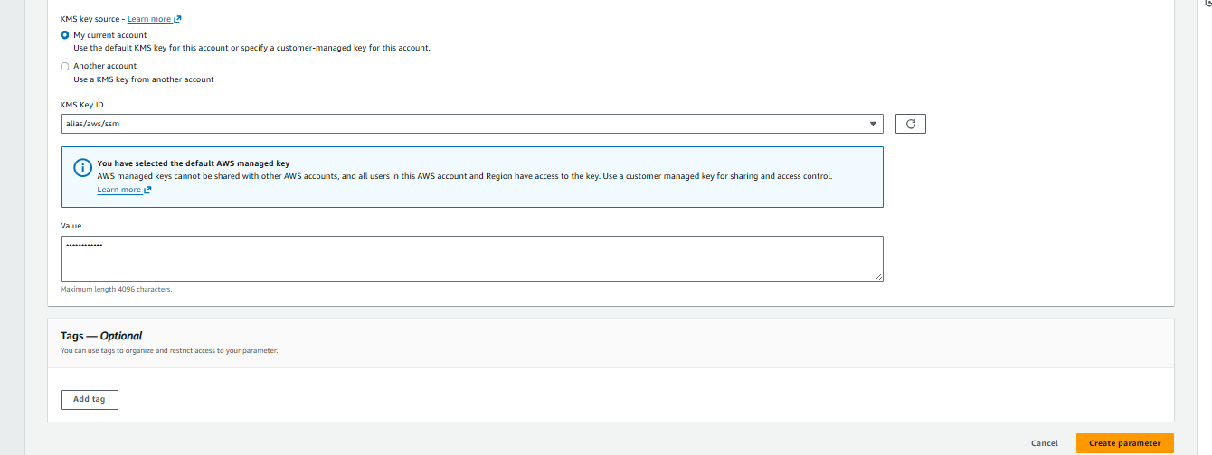
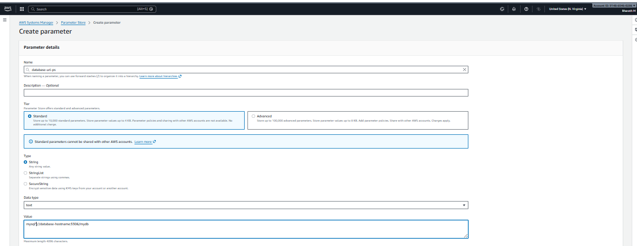
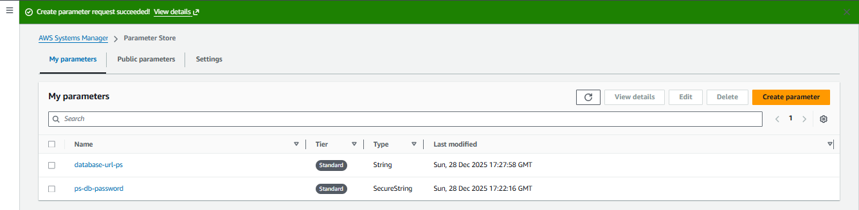

2️⃣ Create IAM Role for EC2
a. Go to IAM → Create Role
- Trusted Entity: AWS Service
- Service: EC2
b. Attach policy
- ✔️ AmazonSSMReadOnlyAccess
c. Name the role
ec2-ssm

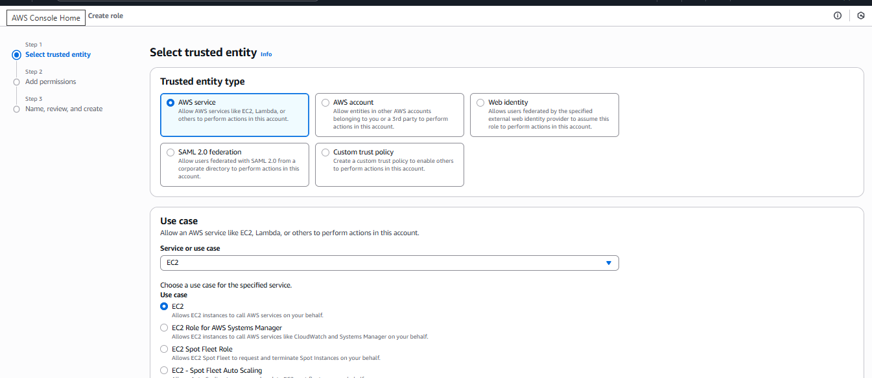
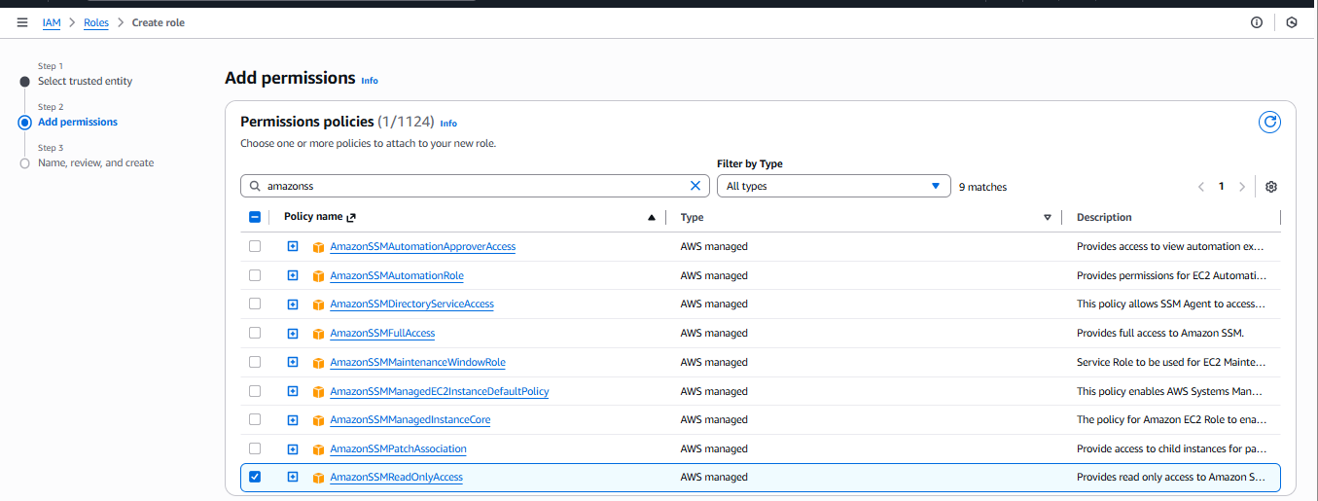
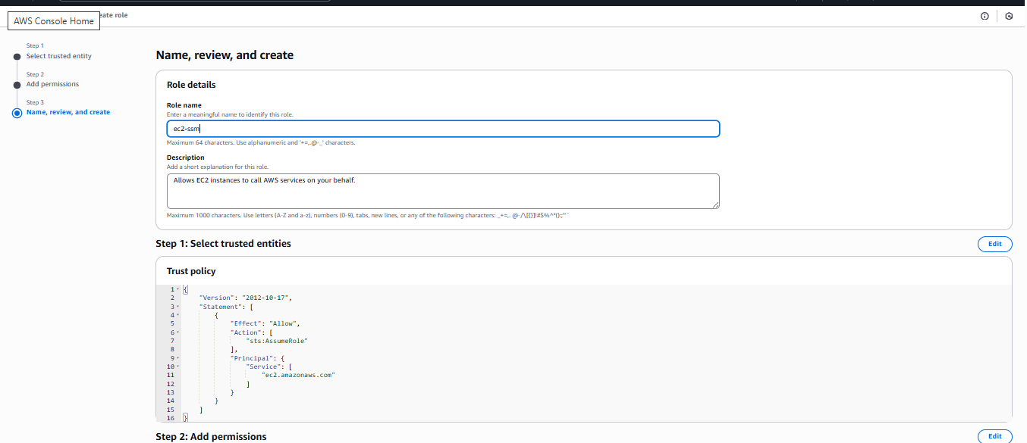
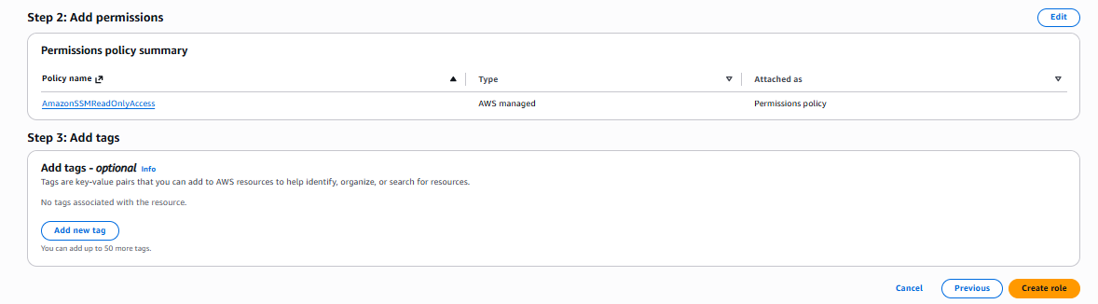

3️⃣ Launch EC2 Instance
- Name: ec2-ps
- AMI: Amazon Linux 2023
- Instance Type: t3.micro
- IAM Role: ec2-ssm
- Security Group: SSH (Port 22)

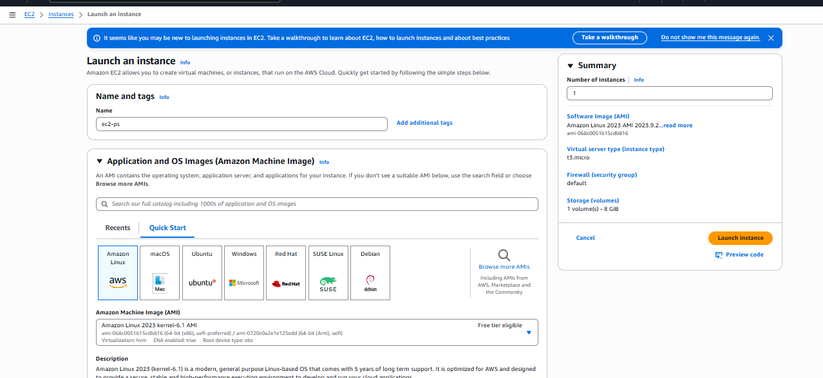
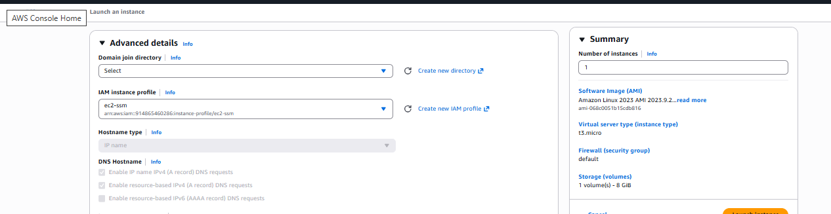

Add User Data Script
Paste in Advanced User Data:
#!/bin/bash
set -e

REGION="us-east-1"

DB_URL=$(aws ssm get-parameter --name "database-uri-ps" --query "Parameter.Value" --output text --region "$REGION")
DB_Password=$(aws ssm get-parameter --name "ps-db-password" --with-decryption --query "Parameter.Value" --output text --region "$REGION")

echo "Database URL: $DB_URL" > /home/ec2-user/db-config.txt
echo "Database Password: $DB_Password" >> /home/ec2-user/db-config.txt

echo "Configuration written to /home/ec2-user/db-config.txt"

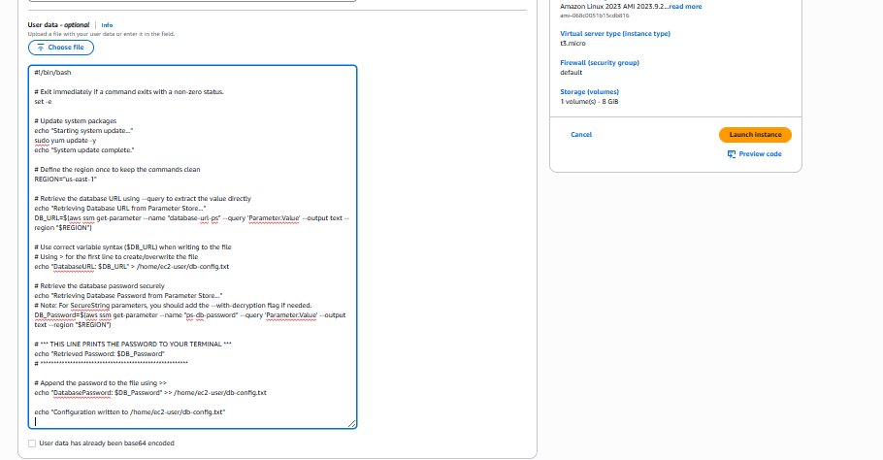

Connect to EC2 & Validate
ssh -i "yourkey.pem" ec2-user@<public-ip>
Run:
cat db-config.txt
Expected Output
Database URL: mysql://database-hostname:3306/mydb
Database Password: MySecurePassword123

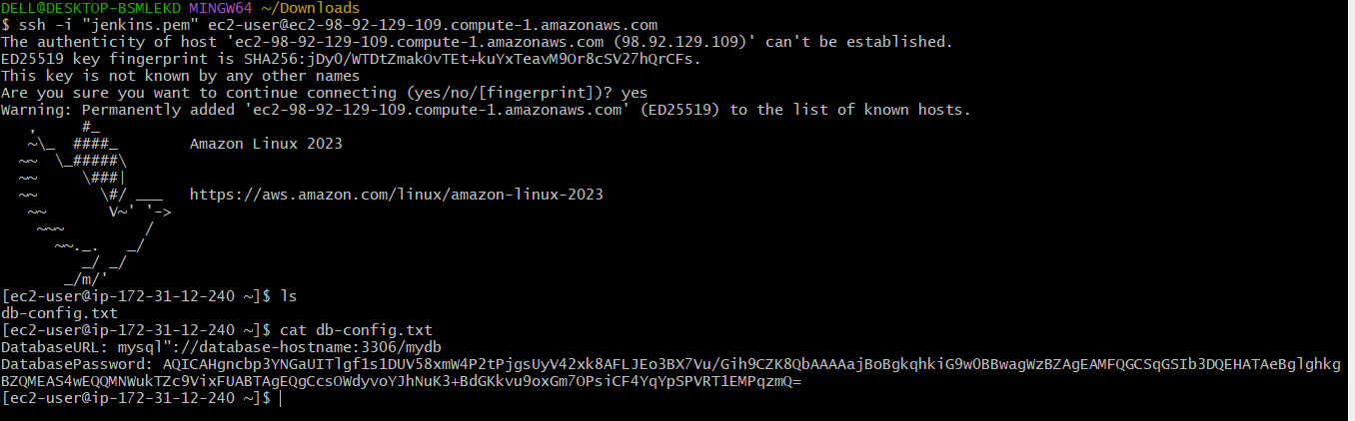

Validation Steps
Check | Command | Expected Result
IAM Role is attached | aws sts get-caller-identity | Shows instance role ARN
SSM Parameter Access | aws ssm describe-parameters | Parameters listed
Values received | cat /home/ec2-user/db-config.txt | URL & password printed

Issues Faced
Issue | Cause | Solution
Password value appeared encrypted | Missing --with-decryption flag | Add --with-decryption to AWS CLI command
Access denied while fetching params | IAM role missing permissions | Add AmazonSSMReadOnlyAccess
aws command not found | AWS CLI missing in instance | Pre-installed on Amazon Linux 2023, install if needed: sudo yum install awscli

Conclusion
- Database credentials were securely stored in AWS Parameter Store.
- EC2 instance successfully retrieved values at boot using IAM Role and User Data.
- Credentials were not hardcoded, ensuring improved security and compliance.
- Setup can now be extended for application-level integration and production workflows.

AWS WAF

Title
Implementing AWS WAF Web ACL to Block Specific IP Traffic on an Application Load Balancer

Objective
To enhance application security by configuring AWS WAF to block incoming traffic from a specific public IP address and validating the restriction by receiving a 403 Forbidden response through the Application Load Balancer.

Prerequisites
- An active AWS account
- Existing Application Load Balancer (ALB) in a running state
- Publicly accessible ALB DNS name
- AWS WAF service access enabled
- Knowledge of your current public IPv4 address

Errors Faced and How They Were Fixed
Error / Issue | Cause | Fix
ALB returning 403 Forbidden | AWS WAF IP-based rule was blocking the client IP | Verified WAF configuration and confirmed block rule was correctly applied
Unable to access application via ALB | Web ACL attached to ALB with Block action | Removed IP from IP set or changed rule action to Allow for testing
Traffic blocked unexpectedly | Incorrect IP CIDR added | Corrected IP to exact /32 CIDR format

Conclusion
AWS WAF was successfully configured with a Web ACL and an IP-based block rule, and it was correctly associated with the Application Load Balancer. Requests originating from the specified public IP were denied as expected, returning a 403 Forbidden response. This confirms that AWS WAF is effectively protecting the ALB by filtering traffic based on IP address rules.

Step 1: VPC and Subnets
- I created a custom VPC n.virginia-vpc with 142.130.0.0/16
- I created two public subnets in us-east-1a and us-east-1c.
- I associated the subnets with a public route table.
- I added a route 0.0.0.0/0 to an Internet Gateway.
Step 2: EC2 Instances
- I launched two EC2 instances (t3.micro) in the public subnets.
- I installed and started Apache using user data.
- I created /var/www/html/index.html with a test message.
- I verified access using the EC2 public IP address.
Step 3: Target Group
- I created a target group with HTTP protocol on port 80.
- I set the health check path to /index.html.
- I registered both EC2 instances and verified healthy status.
Step 4: Application Load Balancer
- I created an internet-facing Application Load Balancer.
- I attached both public subnets to the ALB.
- I configured an HTTP listener on port 80.
- I forwarded traffic to the target group.
- I verified the application using the ALB DNS name

- Public IP Identification
I opened a public IP detection website (whatismyipaddress.com) in the browser and noted my current IPv4 address as 103.160.27.69.

- IP Set Creation in AWS WAF
I navigated to the AWS WAF & Shield console and opened the IP sets section.
I created a new IP set named my-ip-set with Regional scope and IPv4 as the IP version.
I added the IP address 103.160.27.69/32 to the IP set and saved it.

- Web ACL Creation and ALB Association
I went to Protection packs (Web ACLs) and started creating a new Web ACL named my-firewall with Regional scope.
I selected application category Other and application focus Both API and web.
I selected the Application Load Balancer waf-lb under the resources to protect.

- IP Block Rule Configuration
Under initial protections, I chose Build your own pack from all protections.
I created a new IP-based rule named block-ip with the action set to Block.
I configured the rule using IPv4 and specified the IP CIDR 103.160.27.69/32 (using the IP set).
I added the rule to the Web ACL.

- Validation and Testing
I completed the Web ACL creation and verified that waf-lb was listed as an associated resource.
I accessed the ALB DNS name from the same public IP and received a 403 Forbidden response, confirming that AWS WAF successfully blocked the request.

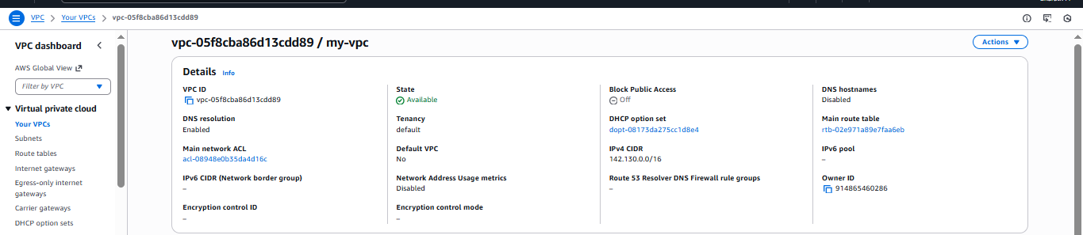
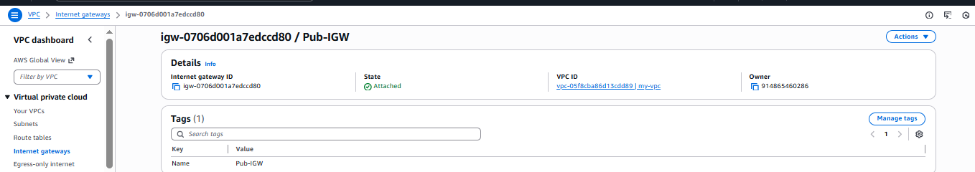
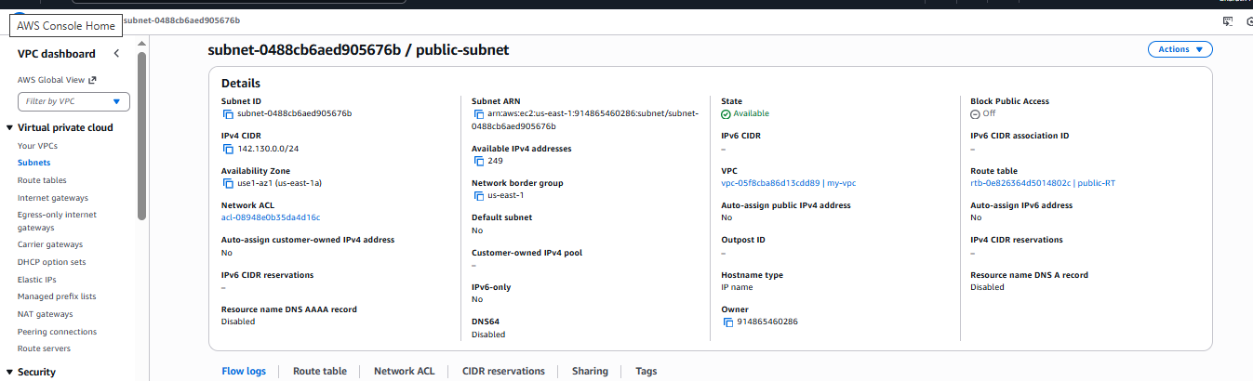
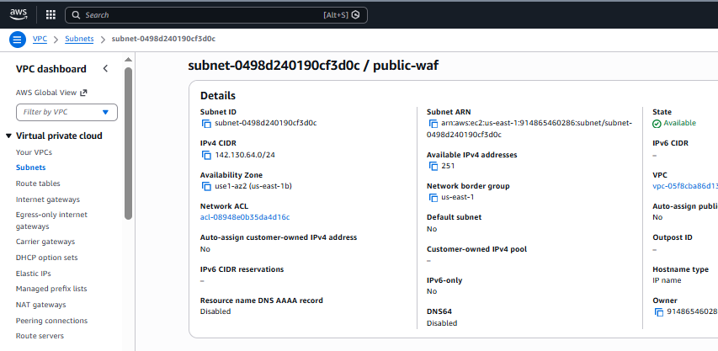
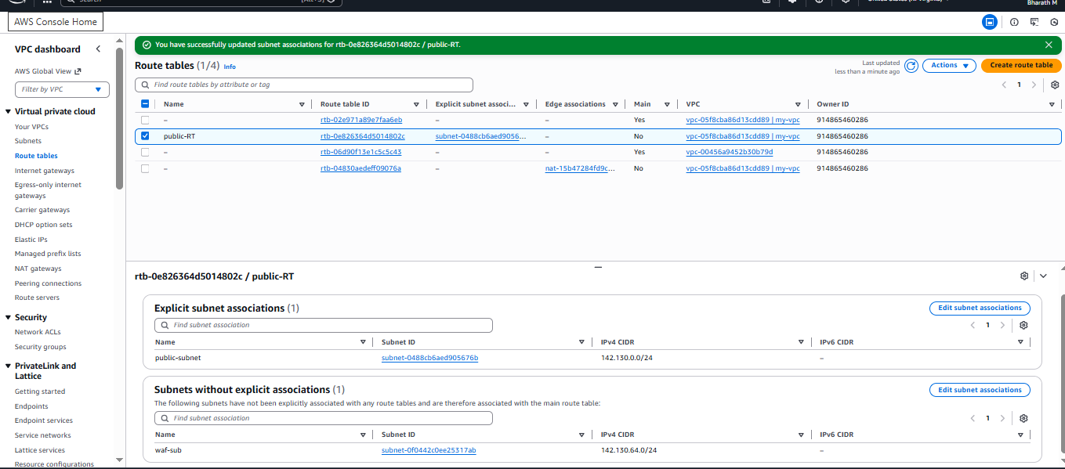
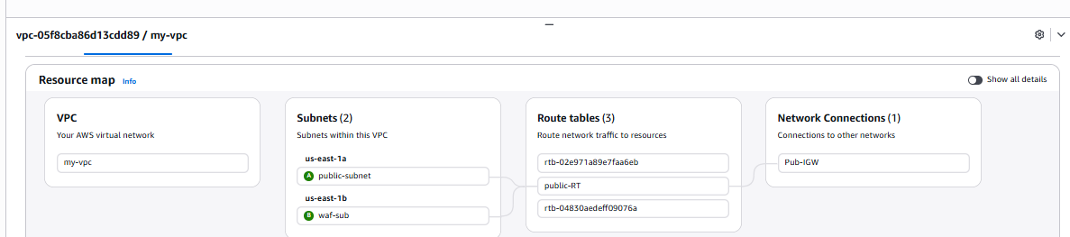
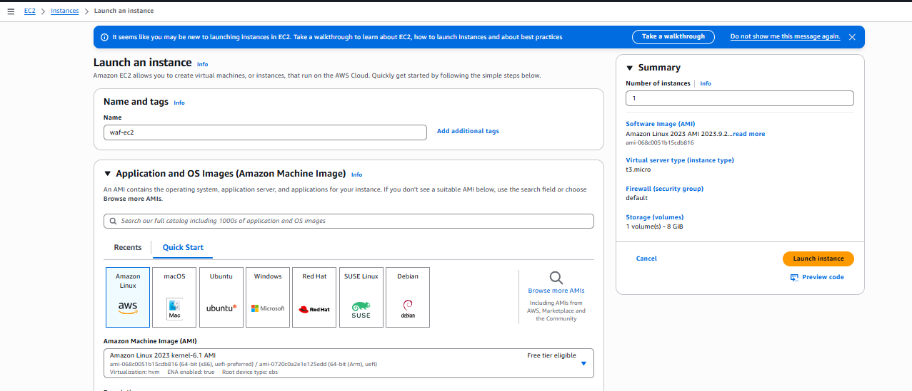
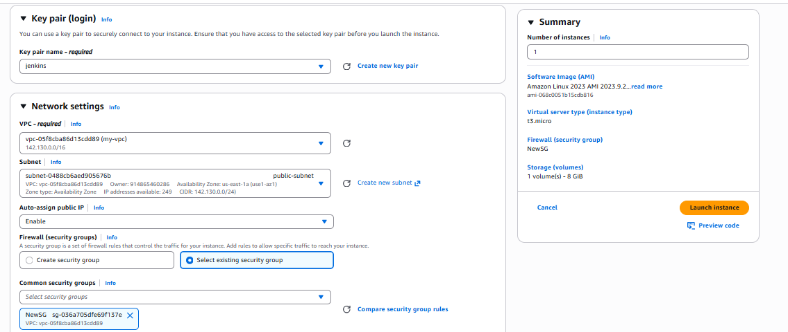
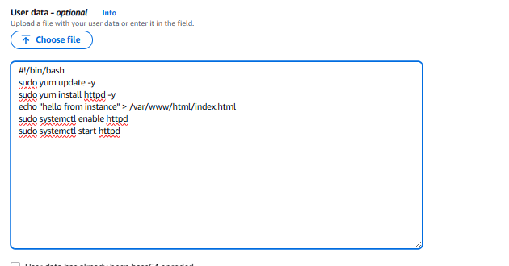
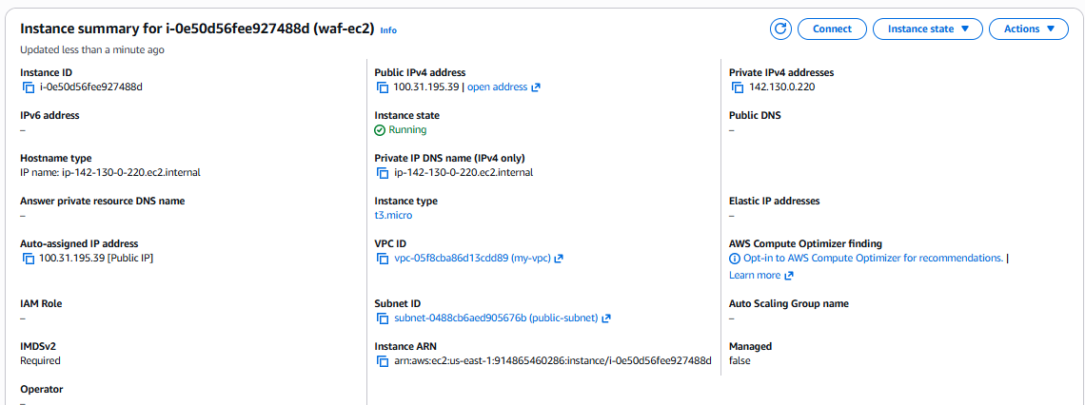
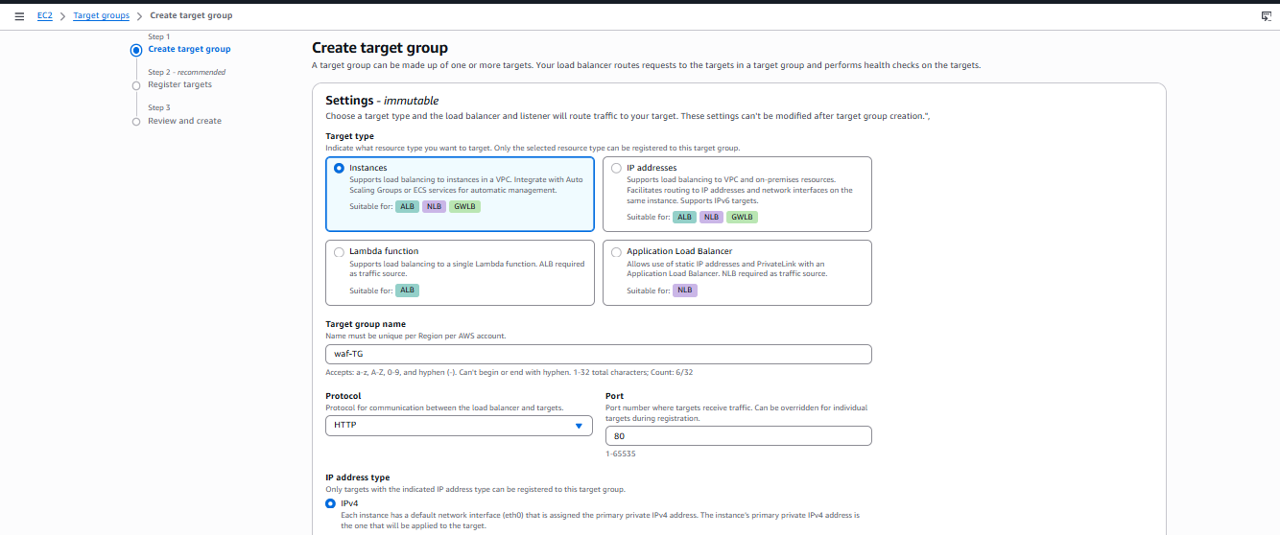
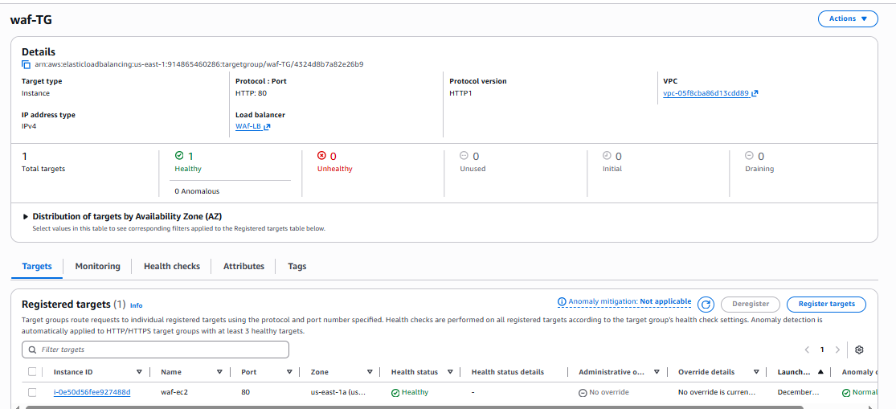

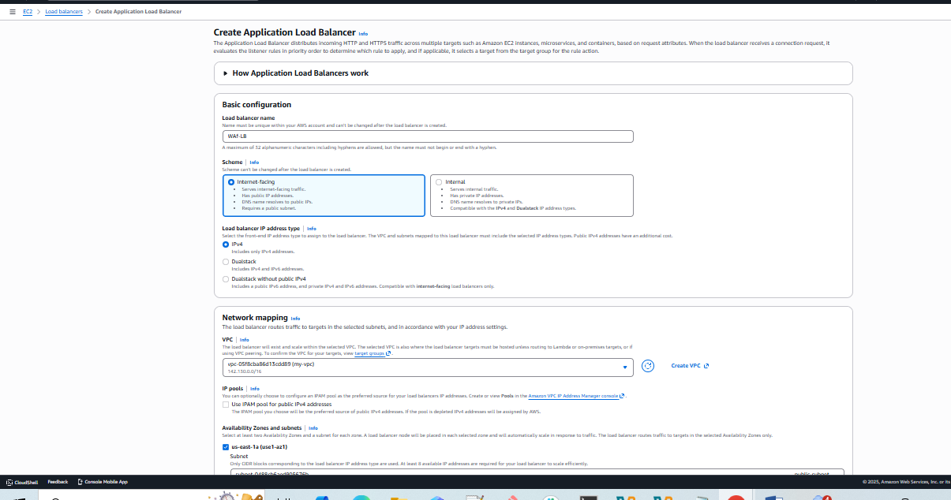
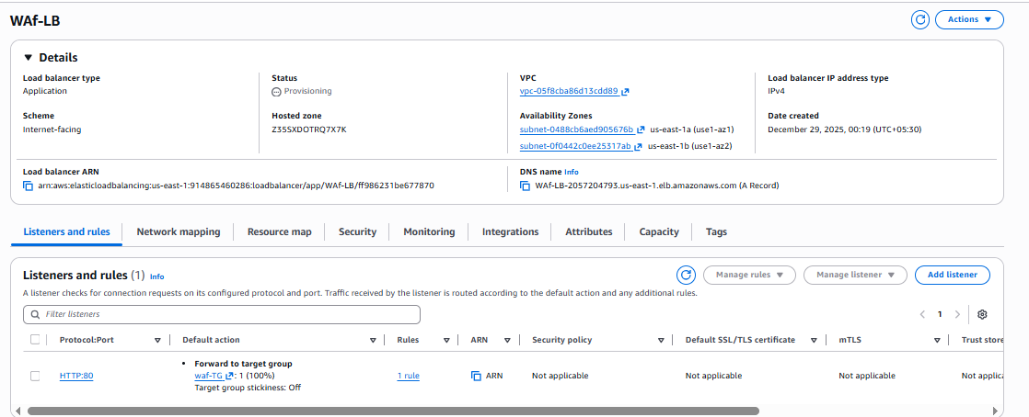
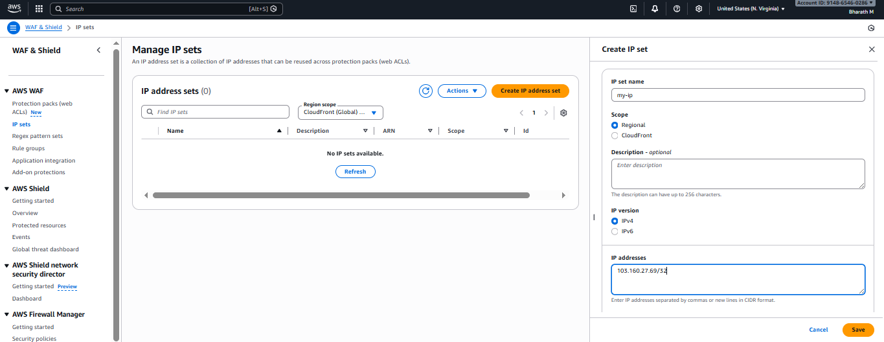
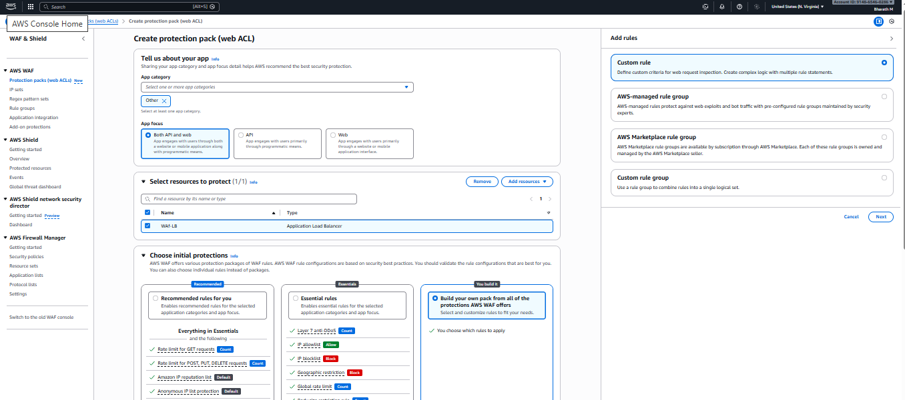
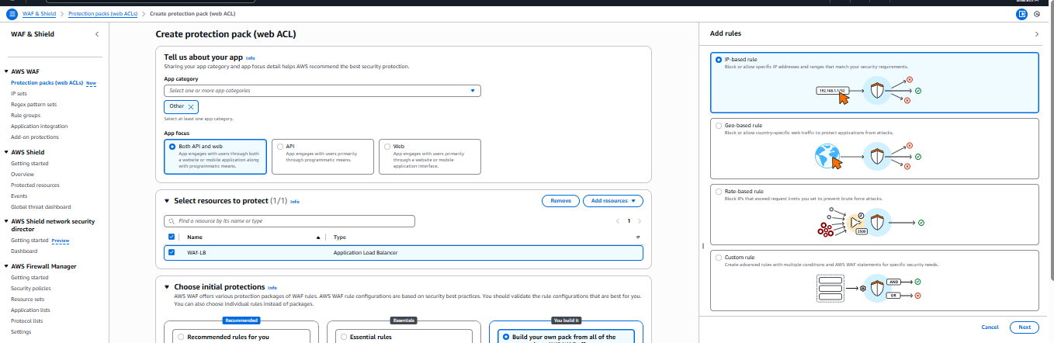
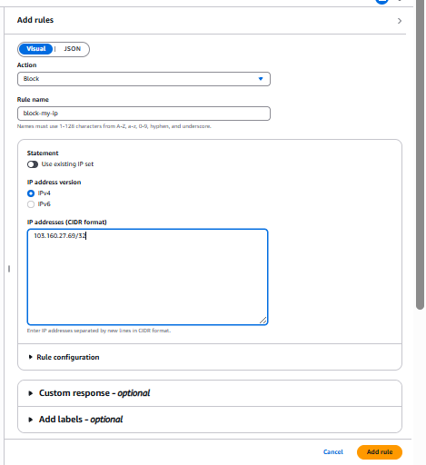
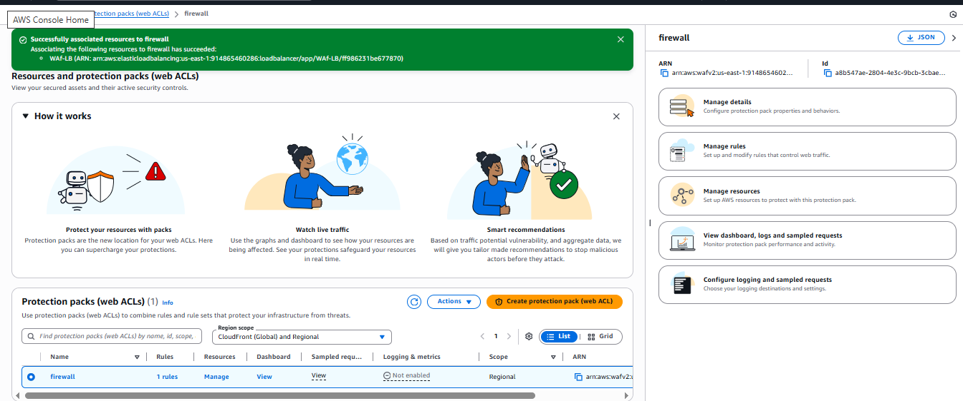

SQS

Task Title
Create and Test an Amazon SQS Standard Queue

Objective
To create a Standard SQS Queue in AWS, configure basic queue settings, send test messages to the queue, and validate message processing and visibility.

Prerequisites
- AWS Account with access to SQS
- IAM user/role with permissions to manage SQS (sqs:CreateQueue, sqs:SendMessage, sqs:ReceiveMessage, sqs:DeleteMessage)
- Basic understanding of AWS Console navigation

Step-by-Step Implementation

1. Create SQS Queue
- Open the AWS Management Console → Search for SQS → Click Create queue
- Queue type: Select Standard
- Name: newqueue
- Configuration settings:
  - Visibility timeout: 30 seconds
  - Delivery delay: 0 seconds
  - Receive message wait time: 0 seconds
  - Message retention period: 4 days
  - Maximum message size: 1024 KB

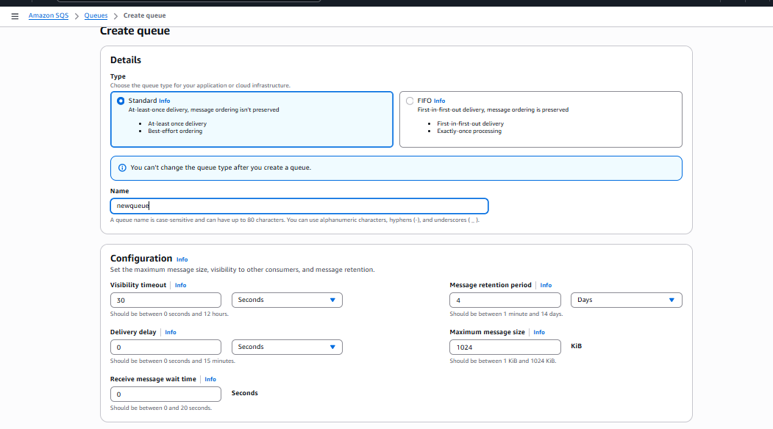

2. Encryption (Optional)
- Server-side encryption: Disabled (As shown)
You may enable SSE-SQS or SSE-KMS if required for data protection.

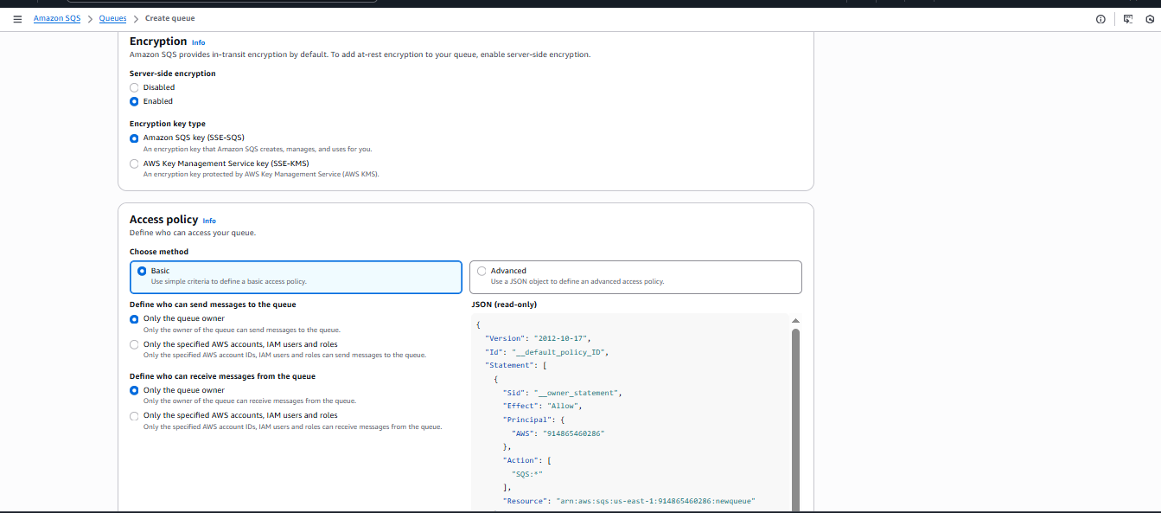

3. Access Policy
- Select Basic
- Allow only the owner to send/receive messages

4. Dead-Letter Queue (Optional)
- Dead-letter queue: Disabled

5. Create Queue
- Click Create queue

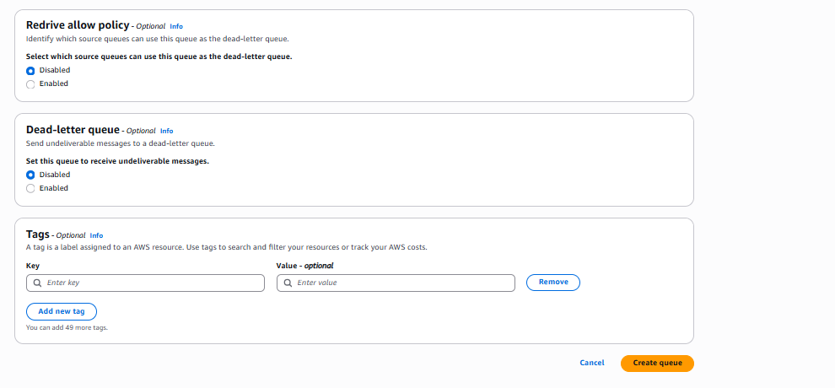
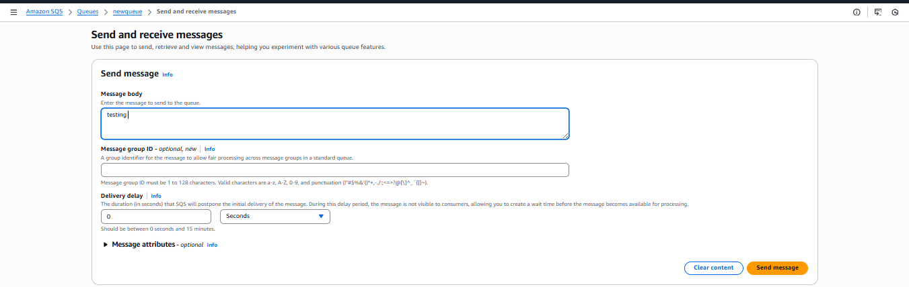
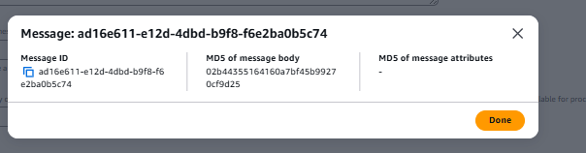
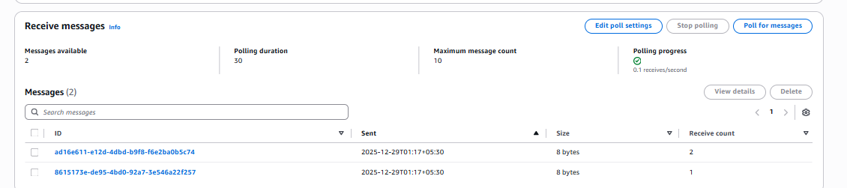
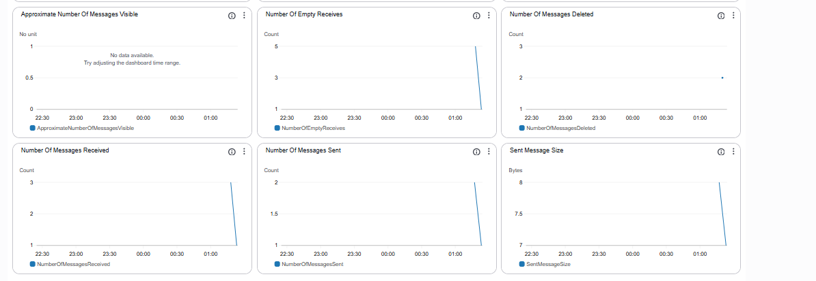

Validation Steps

Send Message
- Open the queue → Select Send and receive messages
- Message body:
- testing
- Click Send message
- Confirm message sent → A message ID is displayed
Example: ad16e611-e12d-4dbd-b9f8-f6e2ba0b5c74

Receive and Poll Messages
- Click Poll for messages
- Messages appear in the queue list
- Validate message details such as ID, Sent time, and Receive count
- Delete messages after validation if needed

CloudWatch Metrics Validation
Navigate to the Monitoring Tab and validate:
Metric | Expected Result
Number of Messages Sent | Shows count after sending messages
Number of Messages Received | Increases when polled
Number of Messages Deleted | Increases if messages are removed
Approximate Number of Messages Visible | Appears based on queue state
Sent Message Size | Shows ~8 bytes for test message

Issues Faced
No major issues encountered.
Possible issues and resolutions:
- Message not visible → Check visibility timeout settings.
- Access denied → Review IAM permissions & access policy.
- Queue not receiving messages → Ensure correct region selection.

Conclusion
A Standard SQS queue named newqueue was successfully created.
Messages were sent, received, and validated using AWS console polling and CloudWatch metrics.
This confirms successful queue functionality and monitoring integration.

MQ

Task Title
Create and Configure Amazon MQ RabbitMQ Broker on AWS

Objective
To provision a RabbitMQ message broker using Amazon MQ, configure access credentials, enable public access, and validate the broker through the RabbitMQ web management console.

Prerequisites
- AWS account with permissions to create Amazon MQ resources (VPC, Subnets, MQ Broker).
- VPC and Subnet available (Public Subnet required if enabling public access).
- Internet connectivity (for accessing the RabbitMQ console).
- Basic understanding of RabbitMQ queues and users.

Step-by-Step Implementation

Step 1: Select Broker Engine
- Navigate to Amazon MQ Console → Brokers → Create broker
- Choose RabbitMQ as the broker engine.
- Click Next.

Step 2: Select Deployment Mode
- Choose Single-instance broker
  - Used for development/testing or smaller workloads.
- Click Next.

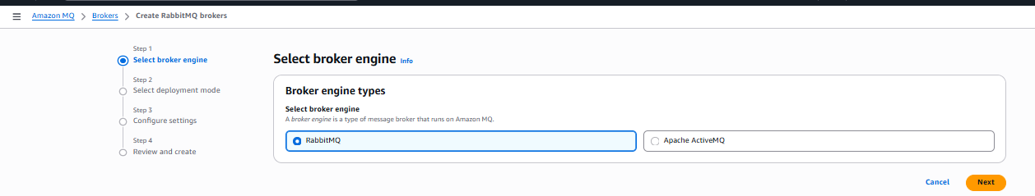
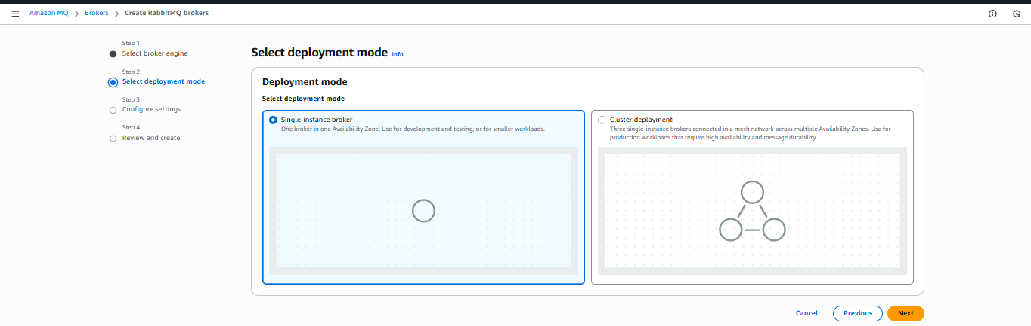

Step 3: Configure Settings
- Broker name: aws-broker
- Instance type: mq.m7g.large
- Storage type: Amazon Elastic Block Store (default)
- RabbitMQ Access
  - Username: admin
  - Password: (minimum 12 characters, secure password as per policy)
- Network & Security
  - Choose VPC & Subnet
  - Enable Public accessibility = Yes
- Keep all other defaults and click Next.

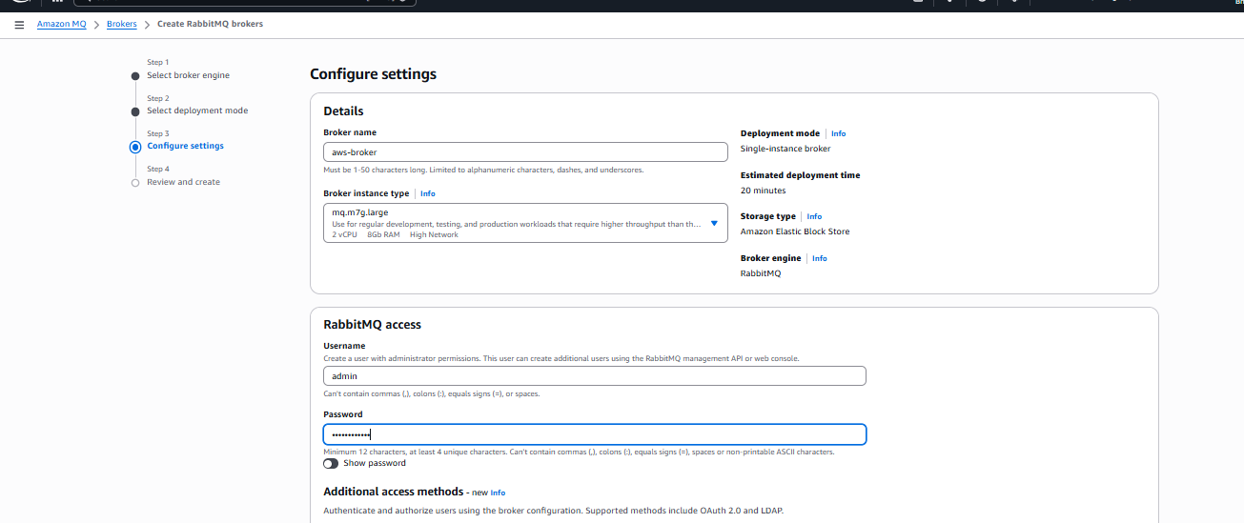
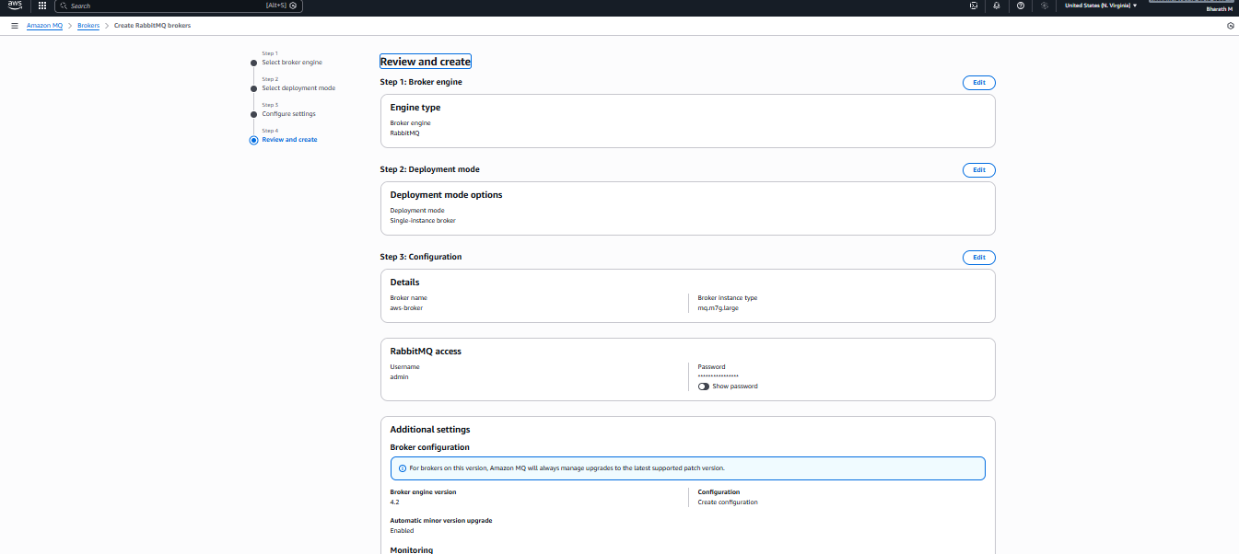

Step 4: Review and Create
- Validate configuration summary.
- Click Create broker.
- Wait for Status → Running (~20 minutes).

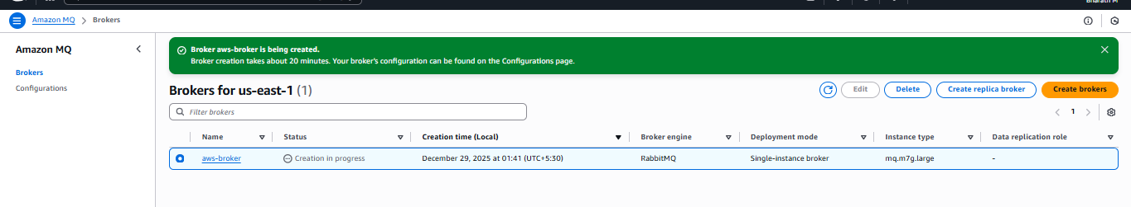
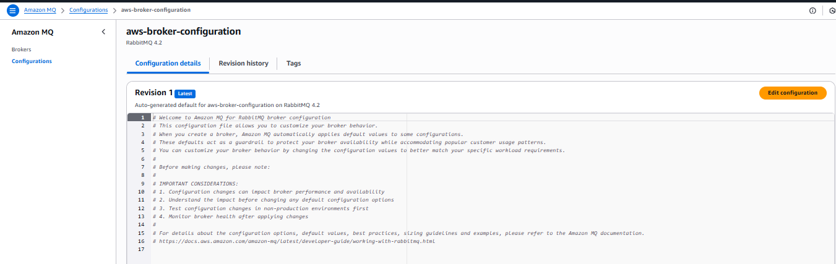
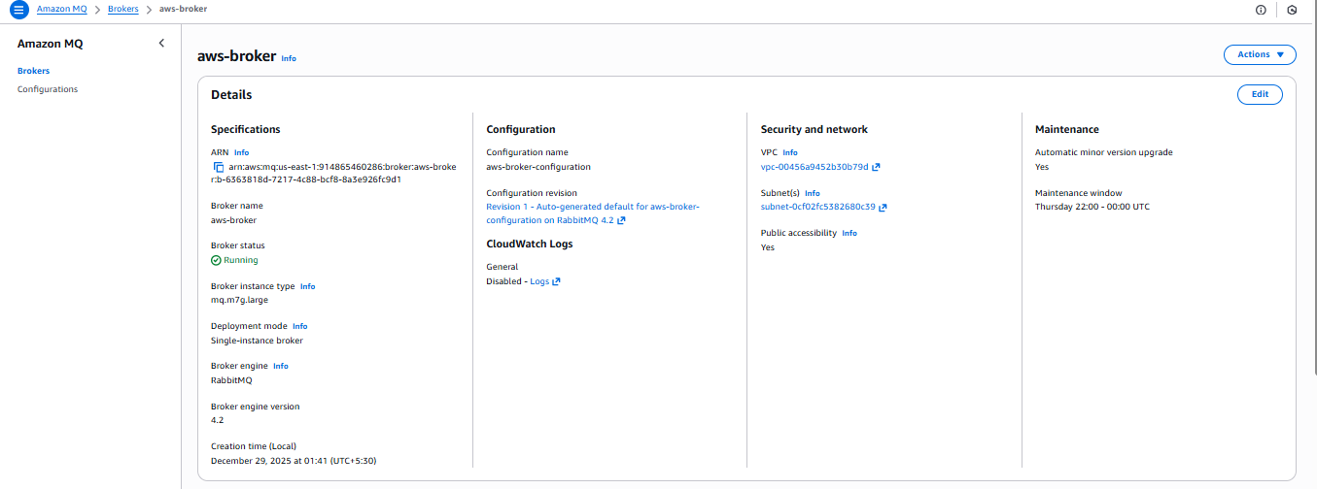
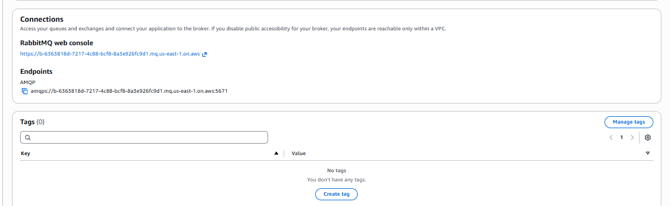

Step 5: Access RabbitMQ Console
Once the broker is running:
- Open RabbitMQ Web Console URL from the broker dashboard:
https://b-<broker-id>.mq.<region>.amazonaws.com
- Login with:
  - Username: admin
  - Password: (same as configured)
- Validate dashboard loads successfully.

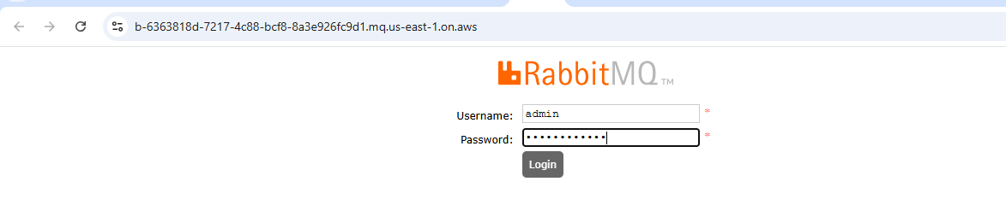
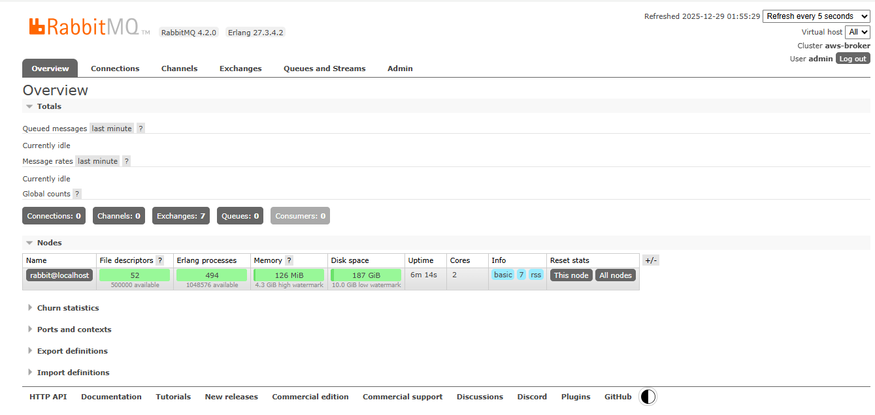
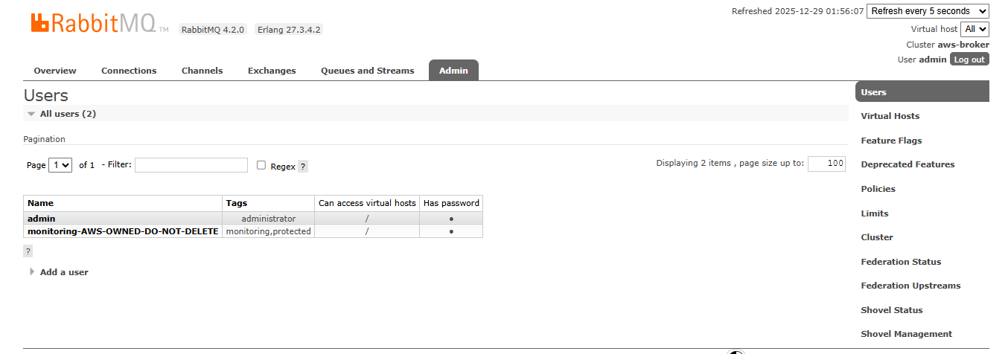

Validation Steps
Validation Check | Expected Result
Broker status | Running
Console Access | Web UI loads successfully
Authentication | Able to login using admin
User list check | admin + AWS system user present
Node uptime & stats | Visible under Overview tab
Screens validated:
- Overview page
- Exchanges, Queues, Users
- AMQP endpoint available
Example AMQP endpoint:
amqps://b-xxxxx.mq.us-east-1.amazonaws.com:5671
Used for connecting apps to the broker.

Issues Faced
Issue | Cause | Resolution
Public URL not accessible | Public access disabled | Recreate broker or modify network settings
Login failed | Password policy not met / wrong entry | Reset using broker configuration update
Broker stuck in provisioning | Incorrect subnet or VPC | Ensure subnet has routing & internet
(Add based on real issues if you face more)

Conclusion
A RabbitMQ broker was successfully created on Amazon MQ using a single-instance deployment.
The broker is publicly accessible with the configured admin user, and RabbitMQ web UI and AMQP endpoint are verified.
This setup is now ready for application integration and message queue operations.

